R.U.S.T. (RESOURCEFUL USERS STREAMLINING TASKS)

Members: Fanlo, Rontale, Suico

Part 2: Design Alternatives

**Project Description: ListMate**

ListMate is designed to revolutionize household organization, particularly in the realm of grocery shopping and everyday essentials. Targeting a broad user base including professionals, students, and families, ListMate offers intuitive features that streamline task management, from meal planning to collaborative shopping lists. By providing a user-friendly interface and customizable options, ListMate optimizes productivity, reduces stress, and enhances the efficiency of household management.

**Requirements Summary**

ListMate must:

1. Be user-friendly and intuitive for a diverse audience.
2. Offer customization to meet individual user needs.
3. Provide offline reminders for due tasks.
4. Send reminders for upcoming tasks.
5. Aid in prioritizing, scheduling, and tracking tasks.
6. Be compatible with various devices such as phones and tablets.

**StoryBoard:**

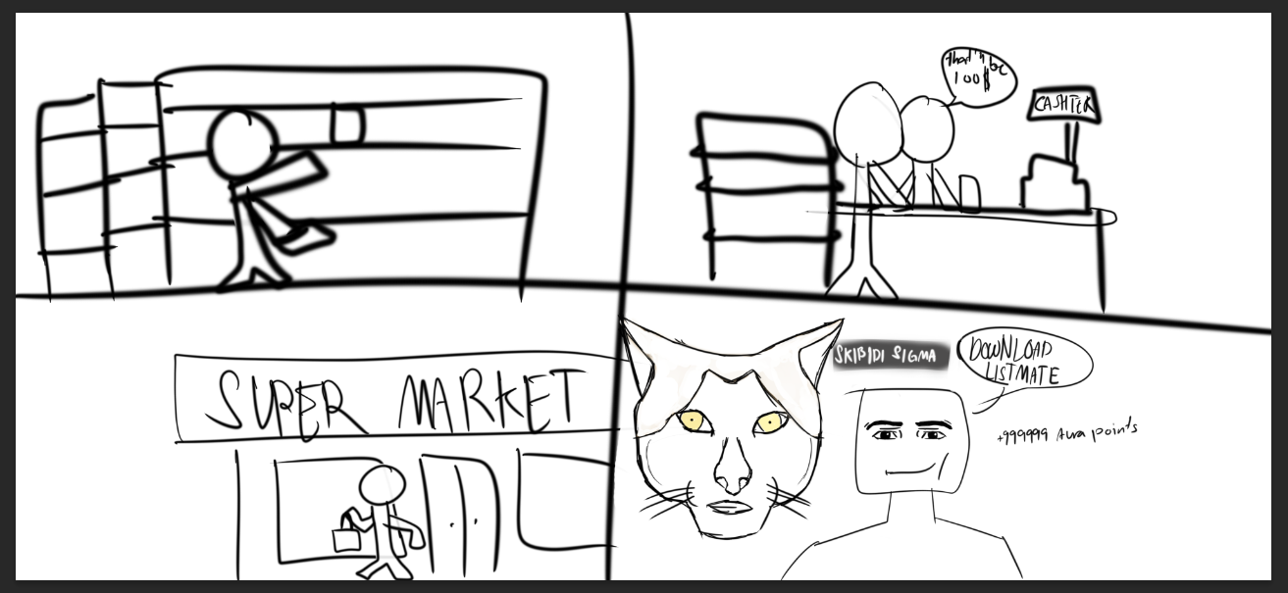

### **First Image Scenario:**

1. **Shopping in the Supermarket**:
   * **Top-left Panel**: A user is browsing the shelves, searching for items. They are using ListMate to ensure they don't forget any items on their list.
   * **Top-right Panel**: At the checkout counter, the user is reviewing their purchases with the cashier. ListMate helps them quickly check off items and ensure they have everything they need.
   * **Bottom-left Panel**: The user is leaving the supermarket, satisfied with their efficient shopping experience. ListMate has made the process smooth and organized.
   * **Bottom-right Panel**: A promotional image highlighting the benefits of ListMate, with a friendly mascot (a cat) and a person recommending to download ListMate. The app offers "+999999 Aura points," emphasizing the rewards and incentives for using it.



### **Second Image Scenario:**

1. **Pre-shopping Preparation and Post-shopping Reflection**:
   * **Top-left Panel**: The user is heading towards the supermarket, ready for their shopping trip. They have ListMate prepared with their shopping list.
   * **Top-right Panel**: Inside the supermarket, the user is using ListMate to navigate the aisles and find items efficiently.
   * **Bottom-left Panel**: The user is shocked or surprised, due to forgetting an important item or an unexpected event. This scenario highlights the importance of having a comprehensive shopping list.
   * **Bottom-right Panel**: The user is looking at their phone with the ListMate app open, possibly realizing they missed an item on their list. This shows the app's role in helping users stay organized and avoid such issues in future trips.

### **Explanation of How ListMate Solves These Problems:**

1. **Pre-shopping Preparation**:
   * ListMate allows users to create detailed shopping lists before they go to the supermarket. This ensures they don't forget any items and helps them plan their trip efficiently.
   * The app offers recipe discovery and meal planning features, enabling users to explore new dishes and add necessary ingredients to their shopping list.
2. **During Shopping**:
   * Users can use ListMate to navigate the supermarket, check off items as they go, and ensure they are sticking to their planned list.
   * The collaborative feature allows family members or housemates to add items in real-time, ensuring the list is always up-to-date.
3. **Post-shopping Reflection**:
   * ListMate helps users review their purchases and make sure they have everything they need.
   * In case they forget something, the app provides a reminder and allows them to quickly add the missing item to their list for the next trip.

### **Benefits Highlighted:**

* **Organization and Efficiency**: ListMate helps users organize their shopping trips, making the process faster and more efficient.
* **Collaborative Planning**: The app allows multiple users to contribute to a shared shopping list, making it easier to manage household needs.
* **Recipe and Meal Planning**: Users can discover new recipes and plan their meals, adding necessary ingredients directly to their shopping list.
* **Smart Suggestions and Personalization**: The app offers personalized recommendations based on users' preferences and shopping history.
* **Rewards and Incentives**: The app provides incentives like Ava points to encourage users to engage with the platform.

**Application Icon**



**Design**

**Color Palettes**

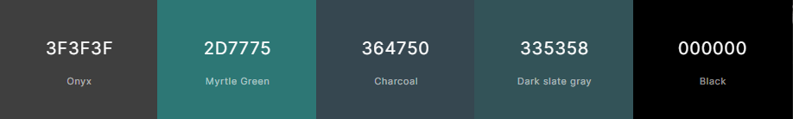

The various color schemes with corresponding codes shown above were chosen to be used in the program. Though it has not been decided upon yet, the palette will be prepared by the time the duo gets closer to the prototyping phase.

**Font**



The team has opted to use Quicksand as the font for the application due to its modern, clean lines and rounded edges. Similar applications such as Slack and Asana have also used this font, and the team has found it to be friendly, readable, and fitting for a modern, approachable design.

**GUI**

The team will only be using the Android GUI for the application to avoid complications that arise from adopting separate GUI designs for different platforms.

**Design Sketches**

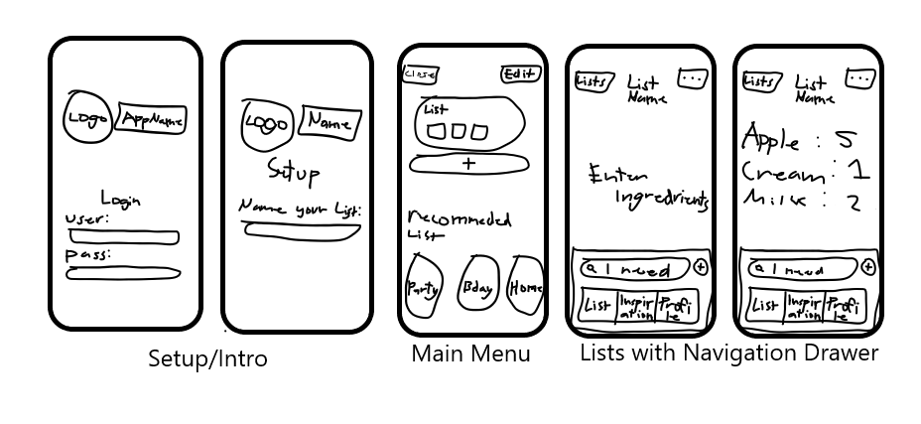

**PROTOTYPE**

**Setup**

The initial user interface of the ListMate app is designed to provide a simple and seamless onboarding experience for new users. Upon opening the app, users are greeted with a sleek and modern welcome screen that prominently features the ListMate logo at the top center. The logo consists of an icon of a shopping cart with a plant and a heart, reflecting the app's focus on household shopping and organization. Below the logo and app name, there are four buttons for users to choose from, each allowing a different method of account creation or login

The ListMate list setup screen guides users to create their first shopping list with a clear prompt asking, "What should your list be called?" and a text input field with example suggestions like "e.g. at home or weekly shopping." The screen features a clean, dark background with the ListMate logo and straightforward instructions for a user-friendly experience.

**Main Menu**

The ListMate "My Lists" screen displays existing lists, such as "Mango Float," and provides options to create a new list or choose from list recommendations like "The other store," "Your next party," and "At your workplace." The interface is clean and organized, featuring easy-to-use buttons for adding new lists and viewing recommended ones.

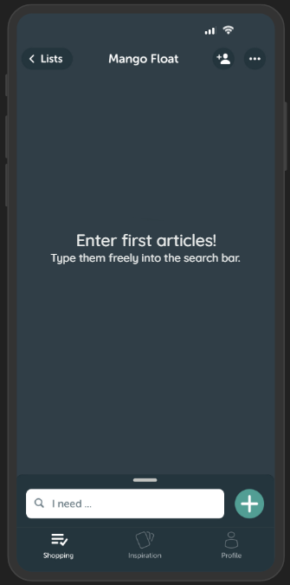

**List with Drawer**

The Listmate app interface shown displays a "Mango Float" list, prompting the user to enter their first articles by typing them into the search bar. The bottom navigation menu includes options for Shopping, Inspiration, and Profile, with a "+" button for adding new items.

The Listmate app interface displays a "Mango Float" list with items such as Mango, Cream, Condensed Milk, and Graham Crackers, each represented by an icon in a red tile. The bottom navigation menu includes options for Shopping, Inspiration, and Profile, with a visible keyboard and a search bar at the top to add new items.

To enhance user convenience, ListMate will now include an offline mode allowing users to access their shopping lists and recipes without an internet connection. Additionally, the app will support voice input for adding items to lists and searching for recipes, improving accessibility and ease of use. Finally, a barcode scanning feature will be added to simplify item entry and provide nutritional information directly from product packaging.